**Abstract**

In the digital age, where first impressions are often made online, the significance of a well-crafted resume cannot be overstated. Recognizing this need, our project endeavors to develop a cutting-edge Resume Builder Website, aimed at simplifying and enhancing the resume creation process for job seekers worldwide.

This project aims to address several key challenges faced by job seekers when crafting resumes. These challenges include time-consuming formatting, difficulty in tailoring resumes to specific job requirements, and limited access to professional design tools. By offering a user-friendly platform with customizable templates and intuitive design features, our website seeks to empower users to create polished resumes efficiently.

The Resume Builder Website will feature a user-friendly interface, allowing users to easily input their personal and professional information. Through an interactive step-by-step process, users will be guided in selecting appropriate templates and customizing layout, fonts, and colors to suit their preferences. Additionally, the website will provide suggestions for relevant skills, experiences, and keywords based on the user's industry and job level, helping to optimize their resume content.

One of the innovative features of our project is the integration of Artificial Intelligence (AI) technology to enhance the resume creation process. Through Natural Language Processing (NLP) algorithms, the website will analyze job descriptions and provide personalized recommendations to users on how to tailor their resumes for specific positions. This functionality will enable users to increase their chances of success by aligning their resumes with the requirements of prospective employers.

**Introduction**

In an era where digital interfaces have become the primary means of communication and interaction, the importance of a well-crafted resume cannot be overstated. A resume serves as the cornerstone of one's professional identity, acting as a vital tool for job seekers to showcase their skills, experiences, and qualifications to potential employers. However, the process of creating a compelling resume is often fraught with challenges, ranging from formatting complexities to the daunting task of tailoring content to specific job requirements.

Recognizing these challenges and the growing demand for streamlined solutions in the job search process, we are excited to introduce our innovative Resume Builder platform. Our platform represents a transformative approach to resume creation, harnessing the power of technology to simplify the process and empower users to present themselves effectively in today's competitive job market.

At its core, our Resume Builder platform is designed to democratize access to professional resume-building tools, making them accessible to job seekers of all backgrounds and skill levels. Whether you're a recent graduate entering the workforce or a seasoned professional seeking new opportunities, our platform offers a user-friendly interface and robust features to meet your needs.

The significance of a well-designed resume extends beyond mere aesthetics; it is a reflection of one's professional identity and potential. With this understanding, our platform prioritizes not only ease of use but also the creation of visually appealing and impactful resumes. Users will have access to a diverse range of professionally designed templates, each meticulously crafted to convey competence, professionalism, and personality.

**Objectives**

**1. Project Development:**

Apply expertise in front-end and back-end technologies to develop innovative and functional projects.

Collaborate with cross-functional teams to translate project requirements into actionable development tasks.

Ensure adherence to project timelines and deliver high-quality solutions that meet or exceed client expectations.

**2. Technical Proficiency:**

Expand knowledge and skills in front-end technologies such as HTML5, CSS3, JavaScript, and popular frameworks like React.js or Angular.js.

Enhance proficiency in back-end technologies including server-side scripting languages like Node.js, Python, or PHP, and databases like MySQL or MongoDB.

Stay updated on emerging trends and best practices in web development to continuously improve technical expertise.

**3. User Experience Enhancement:**

Focus on creating user-centric designs and seamless user experiences through intuitive front-end interfaces.

Implement responsive design principles to ensure optimal performance across various devices and screen sizes.

Leverage user feedback and usability testing to iterate and refine project features for improved usability and satisfaction.

**4. Problem Solving and Innovation:**

Demonstrate strong problem-solving skills to overcome technical challenges and optimize project performance.

Foster a culture of innovation by exploring new technologies and methodologies to enhance project functionalities and efficiency.

Drive continuous improvement initiatives to streamline development processes and maximize productivity.

**5. Team Collaboration and Communication:**

Foster a collaborative work environment by effectively communicating with team members and stakeholders to align on project goals and priorities.

Contribute to cross-functional teams with a positive attitude, sharing insights and best practices to support collective success.

Actively participate in code reviews, brainstorming sessions, and knowledge-sharing activities to foster a culture of learning and growth.

**6. Career Advancement:**

Seek opportunities for professional growth and advancement within the field of web development.

Pursue certifications, training programs, and educational opportunities to further enhance skills and expertise.

Aspire to contribute to impactful projects and make a positive difference in the digital landscape through continuous learning and development.

These objectives provide a clear overview of your aspirations and goals in the context of building projects, highlighting your focus on technical proficiency, user experience enhancement, problem-solving, teamwork, and career advancement. Adjust the details as per your specific career objectives and aspirations.

**Methodology:**

**Front-End Technologies**

**1. Requirement Analysis**

Conduct thorough analysis of project requirements and objectives.

Identify front-end and back-end technology needs based on project specifications.

**2. Technology Selection:**

Evaluate various front-end technologies such as HTML5, CSS3, JavaScript, and frameworks like React.js or Angular.js.

Assess back-end technologies including server-side scripting languages like Node.js, Python, or PHP, and databases like MySQL or MongoDB.

Select optimal technologies based on project scalability, performance, and client requirements.

**3. Front-End Development:**

Utilize chosen front-end technologies to create intuitive user interfaces and engaging user experiences.

Implement responsive design principles to ensure compatibility across multiple devices and screen sizes.

Collaborate with UI/UX designers to translate design mockups into functional front-end components.

**Back-End Technologies**

**4. Back-End Development:**

Develop robust server-side logic using selected back-end technologies to handle data processing and storage.

Design and implement RESTful APIs for seamless communication between front-end and back-end systems.

Implement authentication and authorization mechanisms to ensure data security and user privacy.

**5. Integration and Testing:**

Integrate front-end and back-end components to create a cohesive and fully functional application.

Conduct thorough testing of both front-end and back-end functionalities to identify and address any issues or bugs.

Perform cross-browser and cross-platform testing to ensure compatibility and consistent performance.

**6. Optimization and Performance Tuning:**

Optimize front-end code for faster loading times and improved user experience.

Fine-tune back-end code to enhance application performance and scalability.

Implement caching mechanisms and other optimization techniques to improve overall efficiency.

**7. Documentation and Maintenance:**

Create comprehensive documentation for both front-end and back-end codebases, including setup instructions and API references.

Provide ongoing maintenance and support for deployed applications, including bug fixes and feature enhancements.

Stay updated on latest trends and advancements in front-end and back-end technologies to continually improve development practices.

**FUNCTIONAL REQUIREMENTS**

**Use Case Diagram**

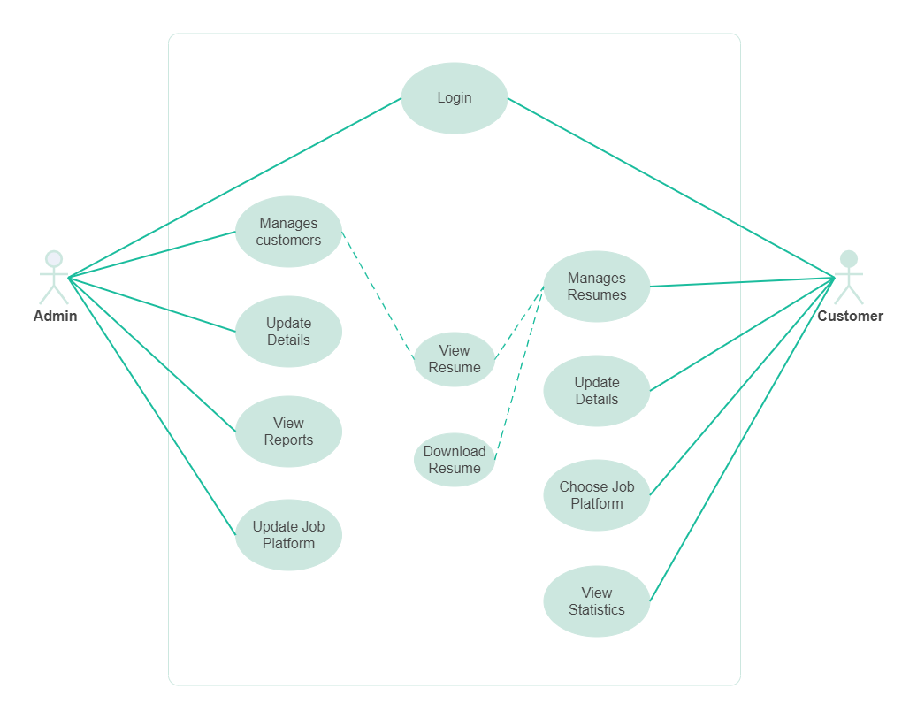

**ER Diagram**

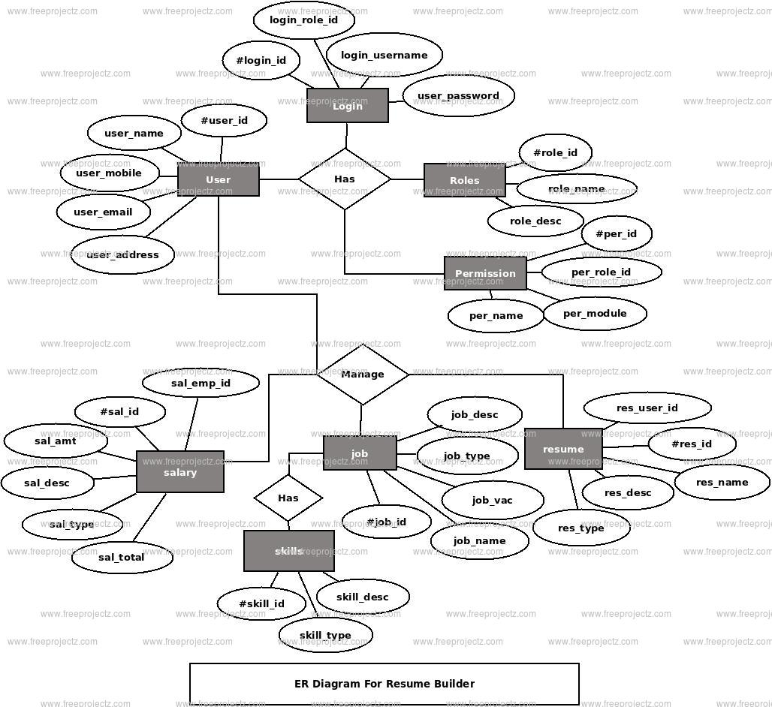

Scope

**1. Platform Overview:**

The project aims to develop a user-friendly online platform for creating and managing professional resumes.

**2. User Features:**

Users can register and create personal profiles.

Users can input and manage various resume sections such as education, work experience, skills, certifications, and projects.

Users can customize the layout, formatting, and order of resume sections.

Users can choose from a selection of professionally designed resume templates.

Users can import data from LinkedIn or other platforms to populate their resume automatically.

Users can collaborate with others and share their resume drafts for feedback.

**3. Resume Creation Process:**

Users can add, edit, and delete content within each resume section.

Users can input their skills and proficiency levels, with the option for the system to suggest relevant skills.

Users can preview their resume in real-time and make adjustments as needed.

Users can export their completed resume in various file formats such as PDF, Word, or HTML.

**4. Technical Requirements:**

The platform will be built using modern web development technologies such as HTML5, CSS3, JavaScript, and a backend framework like Node.js or Django.

The platform will be mobile-responsive, ensuring a seamless user experience across different devices.

Robust data encryption and security measures will be implemented to protect users' personal information.

**5. Project Constraints:**

The project will have a defined timeline and budget for development.

The platform will initially target a specific audience or industry segment.

Certain advanced features such as machine learning-based resume optimization may be considered for future iterations based on resource availability and user feedback.

**6. Deliverables:**

The final deliverable will be a fully functional web-based resume-building platform deployed to a production environment.

Documentation will be provided for system architecture, user guide, and maintenance instructions.

**7. Exclusions**:

The project will not include job search functionalities or job application management.

The platform will not provide career coaching or resume writing services beyond basic guidance and templates.

**8. Assumptions:**

It is assumed that users have basic computer literacy and internet access.

Users are responsible for the accuracy and completeness of the information they input into their resumes.

**9. Risks:**

Risks include potential technical challenges during development, data security breaches, and user adoption issues.

Mitigation strategies will be implemented to address identified risks throughout the project lifecycle.

**10. Stakeholders:**

Stakeholders include project sponsors, developers, users, and potentially third-party integrators (e.g., LinkedIn API).

**Problem Definition:**

**1. Complexity and Time-Consuming Process:**

Many individuals find the process of creating or updating a resume to be daunting and time-consuming.

Formatting issues, content organization, and design choices often lead to frustration and inefficiency.

**2. Lack of Guidance and Resources**:

Individuals may struggle to know what information to include in their resumes and how to present it effectively.

Limited access to professional templates, guidance on industry best practices, and feedback on draft resumes further exacerbate the challenge.

**3. Inconsistent Presentation and Quality:**

Without standardized templates or guidelines, resumes often vary widely in terms of design aesthetics, content quality, and overall presentation.

Inconsistencies in formatting and content may hinder recruiters' ability to quickly assess candidates' qualifications.

**4. Compatibility and Accessibility Issues:**

Traditional resume-building methods such as using word processors or templates may not always produce resumes that are compatible across different devices or software platforms.

Lack of mobile responsiveness and accessibility features can limit users' ability to create and share resumes effectively.

**5. Difficulty in Tailoring Resumes for Different Roles:**

Crafting customized resumes tailored to specific job opportunities requires careful consideration of relevant skills, experiences, and keywords.

Without guidance or tools to streamline this process, individuals may struggle to adapt their resumes for different roles or industries.

**6. Security and Privacy Concerns:**

Sharing personal and professional information on resumes raises concerns about data privacy and security.

Users may hesitate to input sensitive information into online resume-building platforms without assurance of robust data protection measures.

**7. Need for Continuous Updates and Maintenance:**

Resumes are dynamic documents that require regular updates to reflect new experiences, skills, or qualifications.

Lack of efficient tools for managing resume updates may result in outdated or incomplete resumes.

**8. Accessibility for Diverse Audiences:**

Ensuring accessibility for individuals with disabilities, including visual impairments or mobility limitations, is essential for creating inclusive resume-building solutions.

**9. Career Advancement Implications**:

Ineffective resume creation and presentation may negatively impact individuals' ability to secure employment opportunities and advance in their careers.

Addressing resume-building challenges directly contributes to individuals' professional success and opportunities for growth.

This problem definition highlights the key pain points and challenges that individuals face when creating or updating their resumes, providing a foundation for developing effective solutions to address these needs. Adjustments can be made based on specific user demographics, industry trends, and project objectives.

**Resume**

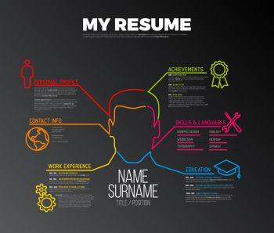

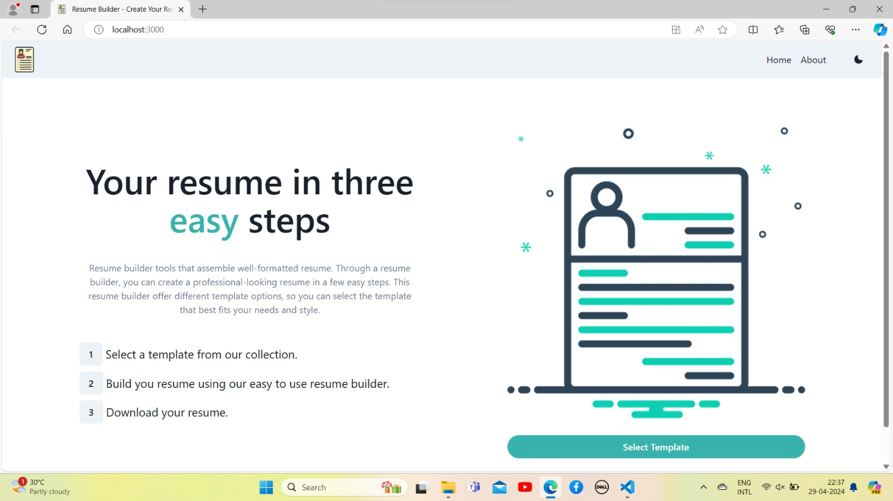

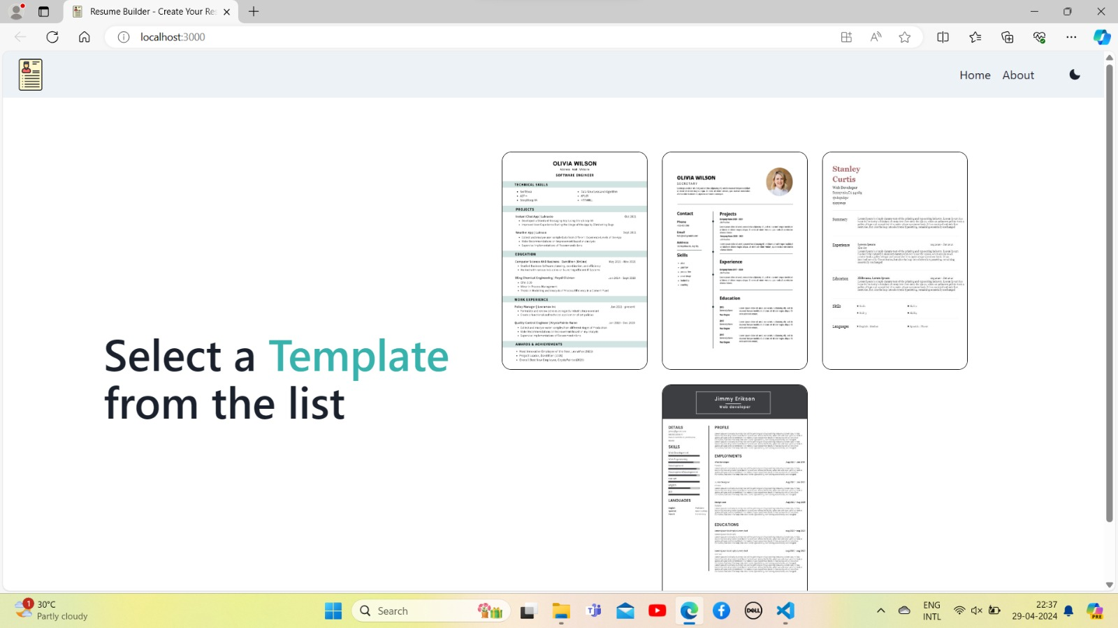

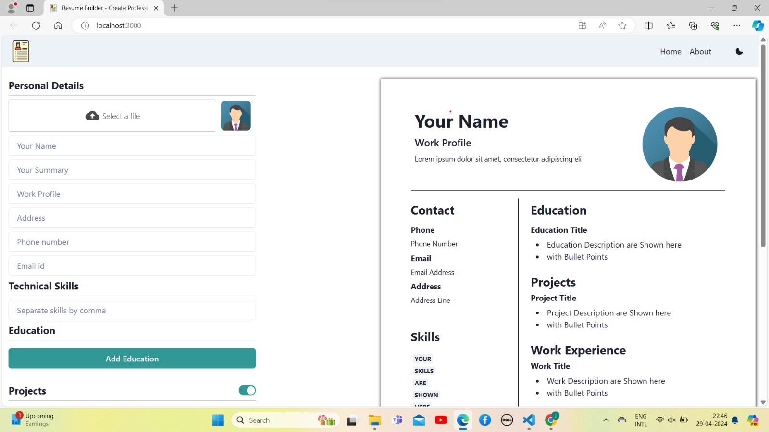

**Results**

1. **Clarity and Readability:**

Ensure your resume is easy to read and understand at a glance. Use clear headings, bullet points, and concise language to convey your skills and experiences.

Relevance: Tailor your resume to the specific job you're applying for. Highlight experiences, skills, and accomplishments that are most relevant to the position.

1. **Achievements:**

Instead of just listing job responsibilities, focus on your accomplishments and contributions in each role. Use quantifiable metrics whenever possible to demonstrate the impact you've made.

1. **Keywords:**

Incorporate relevant keywords from the job description into your resume. Many employers use Applicant Tracking Systems (ATS) to scan resumes for specific keywords, so including them can increase your chances of getting noticed.

1. **Professionalism:**

Make sure your resume presents you in a professional light. Use a clean, professional format and avoid including personal information that's not relevant to the job.

1. **Customization:**

Customize each resume for the job you're applying for. This might involve rearranging sections, emphasizing different skills or experiences, or even creating multiple versions of your resume for different types of roles.

1. **Proofreading:**

Thoroughly proofread your resume to ensure it's free of typos, grammatical errors, and formatting issues. You might even consider asking a friend or mentor to review it for you.

1. **Consistency**:

Maintain consistency in formatting, style, and terminology throughout your resume. This helps to create a cohesive and professional document.

1. **Visibility:**

Make sure your resume is easy to find by uploading it to online job boards, professional networking sites, and your personal website (if you have one).

1. **Continual Improvement:**

Finally, view your resume as a work in progress and be open to continually updating and improving it as your skills and experiences evolve.

By focusing on these results, you can create a resume that effectively showcases your qualifications and helps you stand out to potential employers.

**References**

When building a resume, it's important to consider including references or at least having them prepared for when potential employers request them. Here are some key points to keep in mind regarding references:

1. **Include a References Section:**

In most cases, it's not necessary to include references directly on your resume. Instead, create a separate section titled "References" that you can provide upon request.

1. **Choose Your References Wisely:**

Select references who can speak positively about your work ethic, skills, and character. Ideally, these should be individuals who have supervised or worked closely with you in a professional capacity. Examples include former managers, supervisors, colleagues, professors, or mentors.

1. **Ask for Permission:**

Before listing someone as a reference, always ask for their permission first. This allows them to prepare and ensures they're comfortable providing a reference for you.

1. **Provide Relevant Information:**

When asking someone to be a reference, provide them with relevant information about the job you're applying for and why you believe they would be a good reference. This can help them tailor their comments to the position.

1. **Keep Your References Informed:**

If you're actively job hunting and using references, keep them informed about the jobs you're applying for and any developments in your job search. This allows them to be prepared if they receive a call or email from a potential employer.

1. **Format for Reference List:**

When creating your reference list, include each reference's name, job title, company, contact information (phone number and email address), and a brief description of your relationship with them. Arrange the list in alphabetical order by last name.

1. **Consider Diversity:**

Try to include a diverse range of references that represent different aspects of your professional life, such as different jobs, industries, or educational experiences.

1. **Keep References Updated:**

Periodically check in with your references to ensure their contact information and availability are up-to-date. If someone on your reference list changes jobs or contact information, be sure to update your reference list accordingly.

1. **Be Grateful:**

After using someone as a reference, whether you get the job or not, take the time to thank them for their support and assistance. Showing gratitude reinforces your professional relationships.

By following these guidelines, you can effectively manage your references and present them in a way that enhances your job applications and reflects positively on your candidacy.

**Conclusion**

In conclusion, building a resume is a strategic process aimed at showcasing your qualifications, experiences, and achievements to potential employers. By focusing on clarity, relevance, professionalism, and customization, you can create a resume that effectively highlights your strengths and makes a positive impression. Remember to tailor your resume to each job application, include relevant keywords, and emphasize your accomplishments rather than just listing job duties. Additionally, consider the importance of references and how to manage them effectively, ensuring you have a list of credible individuals who can speak to your abilities and character. Continuously updating and improving your resume, seeking feedback, and staying organized throughout the job application process will help you present yourself as a strong candidate and increase your chances of landing interviews and securing employment opportunities.